Ankita Durgude

Assignment –8

Formatting Query output.

1. **Assume each salesperson has a 12% commission. Write a query on the orders**

table that will produce the order number, the salesperson number, and the amount of the salesperson’s commission for that order.

**Ans:** select Onum , Snum, (Amt*0.12) as 'Salesperson’s Commission' from orders;

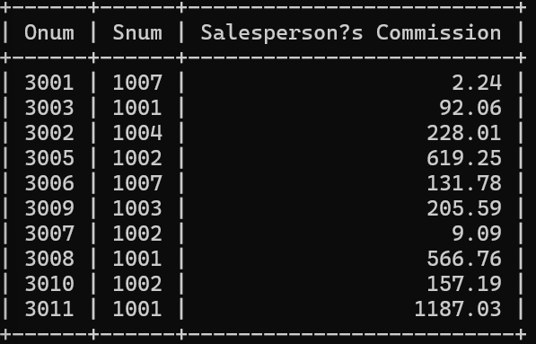

1. **Write a query on the Customers table that will find the highest rating in each city. Put the output in this form:**

For the city (city), the highest rating is : (rating).

**Ans:** select City , max(rating) as rating from Customers group by City;

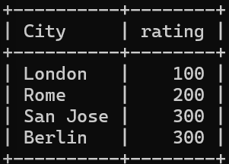

1. **Write a query that lists customers in descending order of rating. Output the rating field first, followed by the customer’s name and number.**

**Ans:** select Rating,Cname,Cnum from Customers order by rating desc;

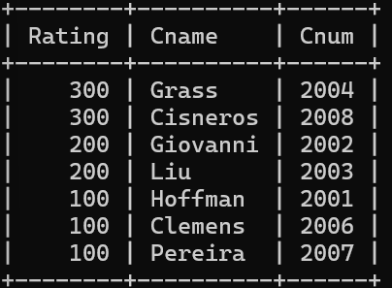

1. **Write a query that totals the orders for each day and places the results in descending order.**

**Ans:** select Odate,count(Odate) as 'total orders' from orders group by Odate order by count(Odate) desc;

